**Technical Written Communication**

Communication is a word of Latin origin- ‘communicare’, which means sharing of information or intelligence, to import or to make common. It may be defined as an exchange of facts, ideas, opinion or emotion between two or more people. Peter little defines communication in his book “Communication in Business” as ‘communication is the process by which information is transmitted between individuals and/or organizations so that an understanding response results”. Technical Communication is the transmission of scientific and technical information from one individual or group to other, and it includes all the methods, mean sand media, channels, networks and systems of communication used for the exchange of the information. Any communication requires the involvement of at least two persons speaker and listener, writer and reader. Language is the most common means of communication. Non verbal means such as physical gestures, body language, facial expressions also contribute to make any communication effective. Non linguistic communications such as traffic signals, road signs, railway signals, telegraphic codes, etc. are also used to convey some feelings ideas or messages. As children, we learn naturally the art of the production of sounds, and sentences in our mother tongue. But as English language has acquired the status of lingua-franca of the world, there is an urgent need for the professionals to have mastery over this means of linguistic communication. It enables individuals to achieve their objectives and goals. It functions as a link between people and one of the most important means to bring them closer. It is impossible to imagine professional life or society without communication. A professional has to face innumerable communication situation in his personal, social and professional life. Communication process initiates the moment one feels to share an idea, a fact, an emotion or an opinion with others. The initiator is called sender or the source, the matter to be communicated is called message. This message is encoded in suitable symbols and transmitted to other person called receiver. The receiver decodes the message, understands it and sends back the appropriate response which is called the feed back. This is the complete process of communication.

Technical communication is a multi-dimensional, dynamic and interactive process that involves the effective transmission of facts, ideas, thoughts and a systematic understanding of scientific and technical subjects. As a dynamic interchange, it is not passive and does not just happen. You actively and consciously engage in technical communication in order to develop information and understanding required for effective professional functioning. It is dynamic because it involves a variety of forces and activities interacting overtime. The word process suggests that technical communication exists as a flow through a sequence or series of steps. As the main purpose of technical communication is to make technologies more useful and meaningful and scientific information more accessible, it serves as a primary communication link between technology and its users.

**TECHNICAL COMMUNICATION PROCESS-** IT CONSISTS OF FIVE STEPS-

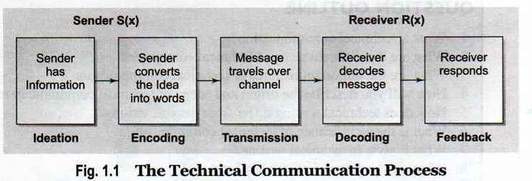

**Ideation-** The process of ideation depends on the formation of the idea or selection of a message to be communicated.Its scope is determined by sender’s knowledge, experiences, abilities and the purpose of communication as wellas the context of the communicative situation.Messages can be divided into two types- logical and emotional. Logical messages contain factual information while the emotional messages consist of feelings and emotions.Ideation may consist of finding and selecting a subject or general topic, looking for ideas and thoughts, and deciding the type, scope, and sources of information.

**Encoding**-This is the process of changing the information into some form of logical and coded message. It involves-

a)selecting a language for communication. Verbal messages use a common language code , shared by both the sender and the receiver. We generally use our mother tongue or Ist language in informal situations whereas we prefer official language in the formal situations.

b) selecting a right medium for communication involves making the right choice out of many available options, it determines the effectiveness of encoding. There are three basic options for sending interpersonal messages, that is speaking, writing and non-verbal signs and symbols.

c) the selection of appropriate form depends on the sender-receiver relationship and the overall goal of the communicative situation. Oral communication may be face to face interpersonal groups, group communication, speaker-audience communication, or telephonic communication. The choice depends on the need and purpose of the communication. Writing involves the selection of correct written form as letter, memo, notice, report, proposal etc.

**Transmission**- It refers to the flow of message over the chosen channel. Transmission confirms the medium and keeps the channel free from all the barriers. It involves choosing the proper time (when), proper place (where), and a proper way (how) to communicate. All these three are needed to be chosen with utmost care for an effective communication.

**Decoding-** It involves the interpretation and analysis of the message. In written communication it means reading and understanding of the message, and in oral communication it includes listening and understanding. Effective decoding is very important for successful communication. Any misinterpretation may create confusion and misunderstanding.

**Response-** This the last stage of communication process. It is the action or reaction of the receiver to the message. It helps the sender know that the message was received and understood. It is the key factor in the communication process that continues the communication further and provides a feedback to the sender if the meaning of the message was correctly received or some clarifications are needed.

**Purpose of Technical Communication**-

There are three **basic purposes** of Technical Writing-

**To Inform**-It is used to communicate information needed by the concerned person.

**To Instruct**-For providing instructions to perform any function.

**To Persuade**- To convince or to change opinions.

**FORMS OF TECH. COMMUNICATION-** There are two forms of technical communication-**oral communication and written communication**

**EXTERNAL COMMUNICATION AND INTERNAL COMMUNICATION-** There are two widely recognized categories of technical communication-external and internal.

**External communication** consists of describing the areas of expertise technical people or professionals provide. This may include any communication between two organizations through letters, external proposals, broachers, information bulletins, instruction manuals etc.

**Internal communication** includes memos describing problems or requesting additional resources, different kinds of reports, internal presentations and proposals, company meetings, policy statements, office instructions, and office descriptions to be used for public release or company websites.

**Features of Technical Writing –**

The acronym ABCCO denotes the key features of technical writing.

**ACCURACY-** Technical writing needs accuracy of information as well as accuracy of expression. Facts have to be recorded carefully and appropriately. Accuracy of expression demands that there should be no errors of grammar, spelling, punctuation or usage. Accuracy of expression demands 'precision' in the use of words, phrases, sentences and paragraphs.

Check the spelling, punctuation and grammar of your sentences and make sure they are correct. If you use a computer spell checker, be careful. Make sure that you know which word to select. Many easily corrected errors in your written work will affect your presentation and your marks. Sometimes you can see errors more easily if you do not proofread your writing until a day or two after finishing writing. This is called 'the drawer treatment'. The Learning Centre has many resources on punctuation, grammar and spelling that you can use.

**BREVITY-** Brevity is the quality of being brief .One must try to be as brief as possible and give maximum information in the minimum number of words possible.

Avoid too many long sentences. Sentences with four or more clauses, or parts, are confusing to read. Your text will probably read better if you consider making two sentences rather than one long sentence. If you want to include a qualification or an example then a long sentence is usually appropriate.

|  |  |
| --- | --- |
| **An example of a long sentence** | *After consulting three manufacturers: Dribble and Co., Sooky Ltd. and Bungle Pty, we have found that there are two types of vibration suppression devices for portable CD players and both are simple in design but have inherent drawbacks.* |
| **More concise sentence** | *Three manufacturers were consulted: Dribble and Co., Sooky Ltd. and Bungle Pty. We found two types of vibration suppression devices for portable CD players. Both are simple in design but have inherent drawbacks.* |

Avoid too many long sentences. One word can be used instead of two or three, then chose the one word (get around = avoid).

**CLARITY-** Clarity contributes to communicative effectiveness. One can not achieve communicative objectives if one is not clear. Clarity is the art of making your idea clear to your audience. Clarity involves both clarity of thought and clarity of expression.

Avoid being unclear and ambiguous. This can happen when you do not specify what you are writing about and can even depend how you use words like 'it', 'this', 'thing', 'way', 'some' etc.

|  |  |
| --- | --- |
| **An example of unclear expression** | *The way we did the experiment was not so successful. Some of what we needed wasn't there.* |
| **An example of clear expression** | *We were unable to complete the experiment. The glass tubing and tripods required for the experiment were not located in laboratory GO25.* |

Do not use contractions of verbs and pronouns as these are 'spoken forms' (doesn't, can't, it's, they're). The formal writing you will do at university and in the workplace will require the full form (does not, can not, it is, they are).

**COMPREHENSIVENESS-**It demands that the document should be complete with all information that readers will need.

**OBJECTIVITY-**Technical writing involves an objective and systematic discussion, analysis and interpretation of facts rather than expression of sentiments and emotions. In fact, technical writing is on an objective and impersonal presentation of facts.

**THE FLOW OF COMMUNICATION-** A formal communication channel refers to the formal methods of communication that are followed in management. Information flows in an organization both formally and informally. Four different channels of communications are used within an organization.

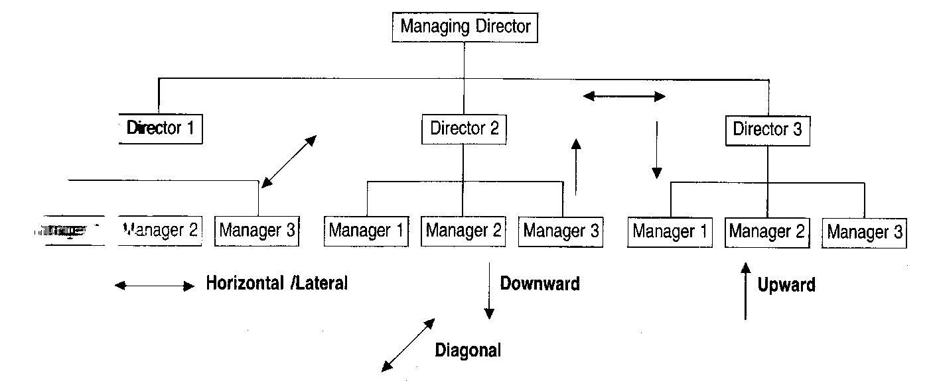

**DOWNWARD COMMUNICATION-**It refers to communication from the higher level in managerial hierarchy to the lower ones. Its main function is to provide direction and control. Examples of downward communication include annual confidential reports, performance appraisals, notices, project feedback, announcement of company policies, official instructions and so on.

**UPWARD CHANNEL-**This channel involves communication from subordinates to superiors. Its main function is to provide feedback on several areas of organizational functioning. Examples of upward channels include reports, business proposals, suggestion box, exit interviews, grievance committee and so forth.

**HORIZONTAL COMMUNICATION-** The main function of horizontal communication is to develop team work, and promoting group coordination within the organization. It takes place between the professional peer groups or people working on the same level of hierarchy. It is less formal or structured than both upward and downward communication, and may be carried out through informal discussions, management gossips, telephone calls, teleconferencing, video conferencing, memos, routine meetings, and so on.

**DIAGONAL CHANNEL-** It occurs between people who do not have to follow very rigid norms of communication protocol and it flows in all directions.

**GRAPEVINE-**The interaction between the different individuals working in a company or organization takes place through different channels. These channels could be both formal and informal. Informal channels transmit official news through unofficial and informal communicative interactions known as the 'grapevine'. This informal communication network includes tea time gossip, casual gatherings, lunch time meetings and so on. These channels may not be reliable. The grapevine is not always negative for the organization and can be helpful as it helps in positive group building by acting as a safety valve for pent up emotions. It may help in building up organizational solidarity and harmony.

**COMMUNICATION NETWORKS-**A variety of networks form while carrying out vertical or horizontal channels. These patterns are called as communication networks.

**Barrier to communication**

One, who knows to give proper attire to his/her ideas, can be successful in today’s global scenario. Technical professional should know how to communicate effectively with his colleagues, friends and relations. If he gets the right response it means he has achieved his objective. The success graph of any organization depends largely on effective communication networks and patterns. Many times we have to suffer due to poor communication skills. Factors responsible for the breakdown of communication process are known as barriers to communication. These should be curved to bridge the communication gap. First of all one must identify these barriers-Physical Barrier:- We need to create a conducive environment for effective communication. Physical discomfort, loud noises, unbearable weather conditions, mental or physical illness etc. are some of the factors that hinder proper communication. Faulty seating arrangements, disturbed phone line, illegible handwriting, defective microphones, defective sound system etc. are some of conditions that can become barrier to effective communication.

Psychological Barrier:- Negative attitude hostile opinions, personal differences, mental or physical stress, emotional condition, disturbed state etc. are some of the factors that pose as psychological barriers to communication, G. K. Chesterton an English essayist, has rightly pointed out that ‘in all the world there is no such thing as an uninteresting subject. There are only uninterested people’.

Faulty organizational network: - The administrative hierarchy of an organization shows the flow of information. It the information passes through many channels to come to its destination, obviously it gets corrupted and distorted. The hesitation of the subordinates to reach to the top most authority creates this problem. So a direct access from bottom to top and vice versa on the ladder of communication should be developed for the correct delivery of the knowledge. Overflow of information also creates confusion. So, only the concerned person should be given the information in nut shell, devoid of useless details.

**CLASSIFICATION OF BARRIERS-** These barriers are classified according to the process of message formation and delivery-

* Intrapersonal
* Interpersonal
* Organizational

**INTRAPERSONAL BARRIERS** Each of us interpret the same information in different ways as our thinking varies. We judge any situation on the basis of various factors-

* Wrong assumptions
* Varied perceptions
* Differing background
* Wrong inferences
* Impervious categories
* Categorical thinking

**INTERPERSONAL BARRIERS-** Interpersonal barriers occur due to the inappropriate transaction of words between two or more people. These arise because of communication gap. The common reasons of this type of barrier are-

* Limited vocabulary
* Misinterpreted verbal or non-verbal messages
* Emotional outbursts
* Communication selectivity
* Cultural variations
* Poor listening skills
* Noise in the channel

**ORGANIZATIONAL BARRIERS-** These exist in the whole organization. In organizations with many levels of communication, messages have a greater chance of being distorted. This occurs due to the following reasons-

* Too many transfer stations
* Fear of superiors
* Negative tendencies
* Use of inappropriate media
* Information overload

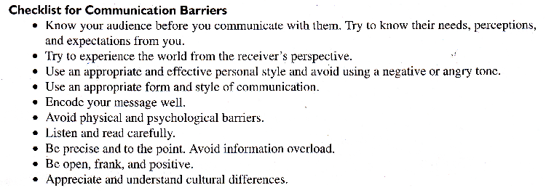

**Distinction between General and Technical Communication**-

|  |  |  |
| --- | --- | --- |
| **General Communication** | **Technical Communication** | |
| Contains general message | Contains a technical message | |
| Informal in style | Mostly formal | |
| No set pattern of communication | Follows a set pattern | |
| Mostly oral | Both oral and written | |
| Not always for a specific audience | Always for a specific audience | |
| Doesn’t involve the use of technical vocabulary or graphics, etc | Frequently involves jargon, graphics, etc. | |
| May not be factual | Always factual | |
| Both objective and subjective | objective | |
| Not always structured | Logically organized and structured | |
| No specific exposition techniques | Complex and structured exposition techniques | |
| May or may not involve graphics | Usually involves graphics | |
| No formal elements | Formal elements | |
| **General Communication** | | **Technical Communication** | |
| Contains general message | | Contains a technical message | |
| Informal in style | | Mostly formal | |
| No set pattern of communication | | Follows a set pattern | |
| Mostly oral | | Both oral and written | |
| Not always for a specific audience | | Always for a specific audience | |
| Doesn’t involve the use of technical vocabulary or graphics, etc | | Frequently involves jargon, graphics, etc. | |
| May not be factual | | Always factual | |
| Both objective and subjective | | objective | |
| Not always structured | | Logically organized and structured | |
| No specific exposition techniques | | Complex and structured exposition techniques | |
| May or may not involve graphics | | Usually involves graphics | |
| No formal elements | | Formal elements | |
| **General Communication** | | **Technical Communication** | |
| Contains general message | | Contains a technical message | |
| Informal in style | | Mostly formal | |
| No set pattern of communication | | Follows a set pattern | |
| Mostly oral | | Both oral and written | |
| Not always for a specific audience | | Always for a specific audience | |
| Doesn’t involve the use of technical vocabulary or graphics, etc | | Frequently involves jargon, graphics, etc. | |
| May not be factual | | Always factual | |
| Both objective and subjective | | objective | |
| Not always structured | | Logically organized and structured | |
| No specific exposition techniques | | Complex and structured exposition techniques | |
| May or may not involve graphics | | Usually involves graphics | |
| No formal elements | | Formal elements | |